**Laboratory work 3**

**1. Select all the data of passengers whose last name is same as first name.**

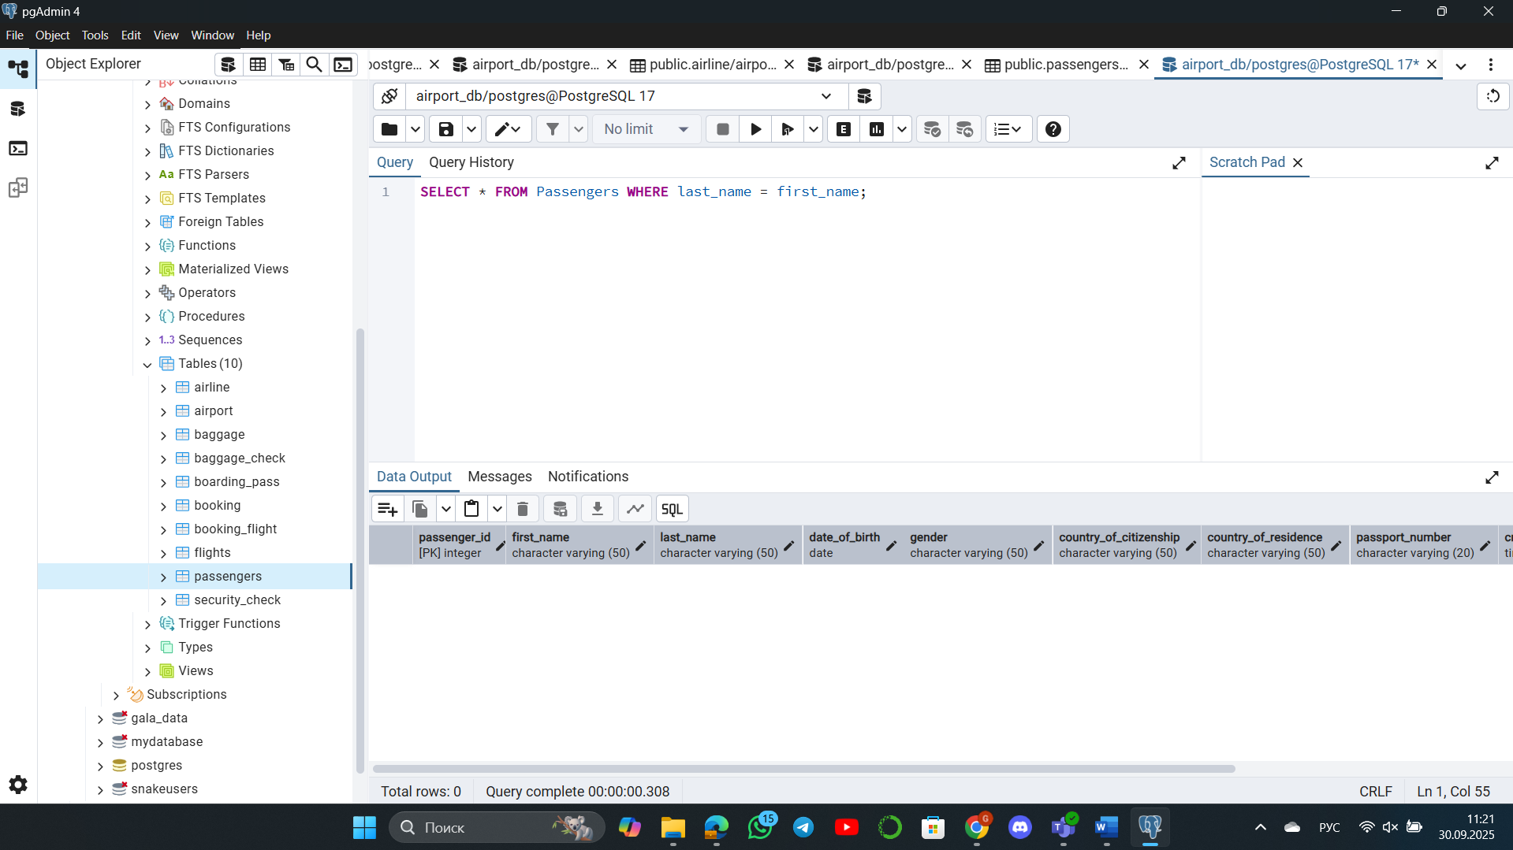

The query was successful but returned no rows. This means the current dataset contains no passengers whose names match the family.

**2. Select the last name of all passangers without duplicates.**

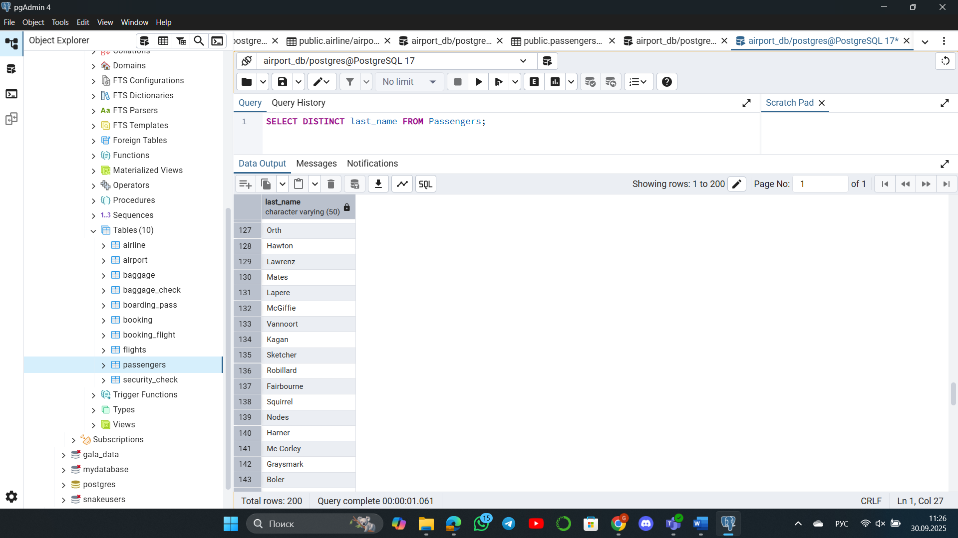

**3. Find all male passengers born between 1990 and 2000.**

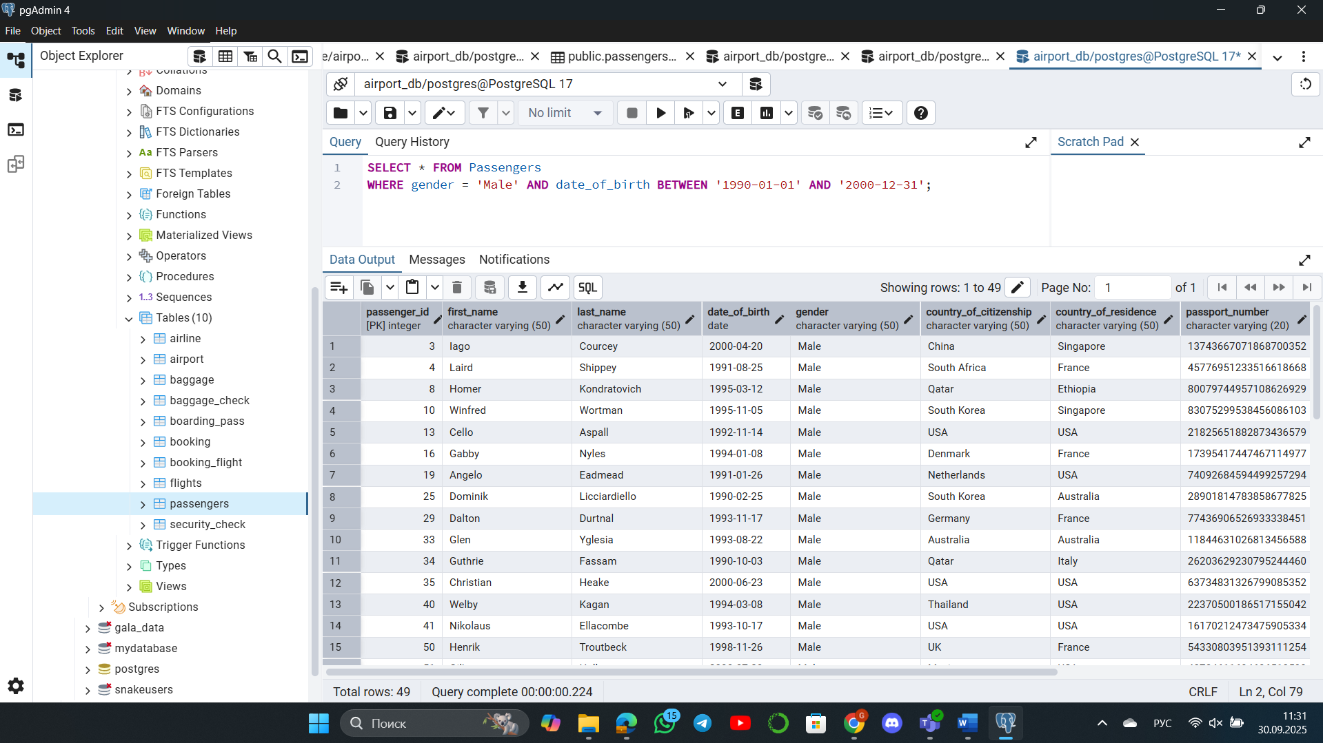

**4. Find price of tickets sold for each month in sorted way.**

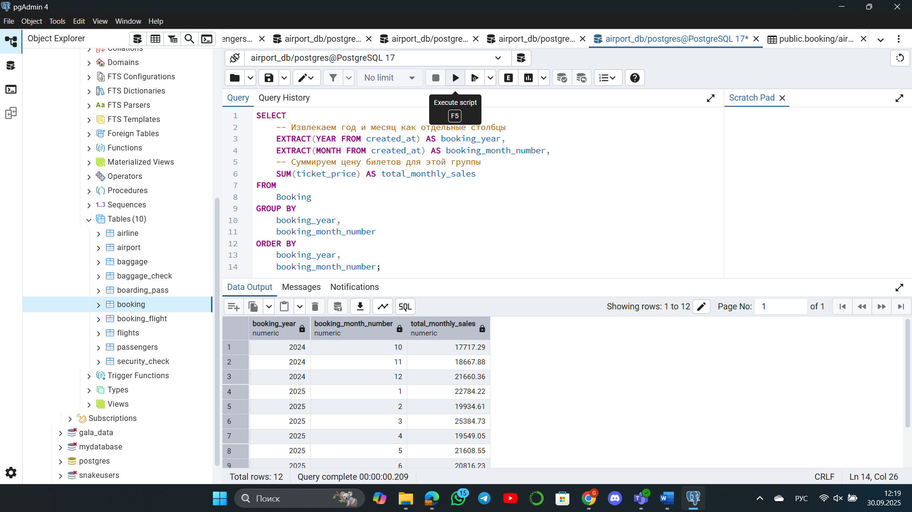

**5. Create a query that shows all flights flying to ‘China’.**

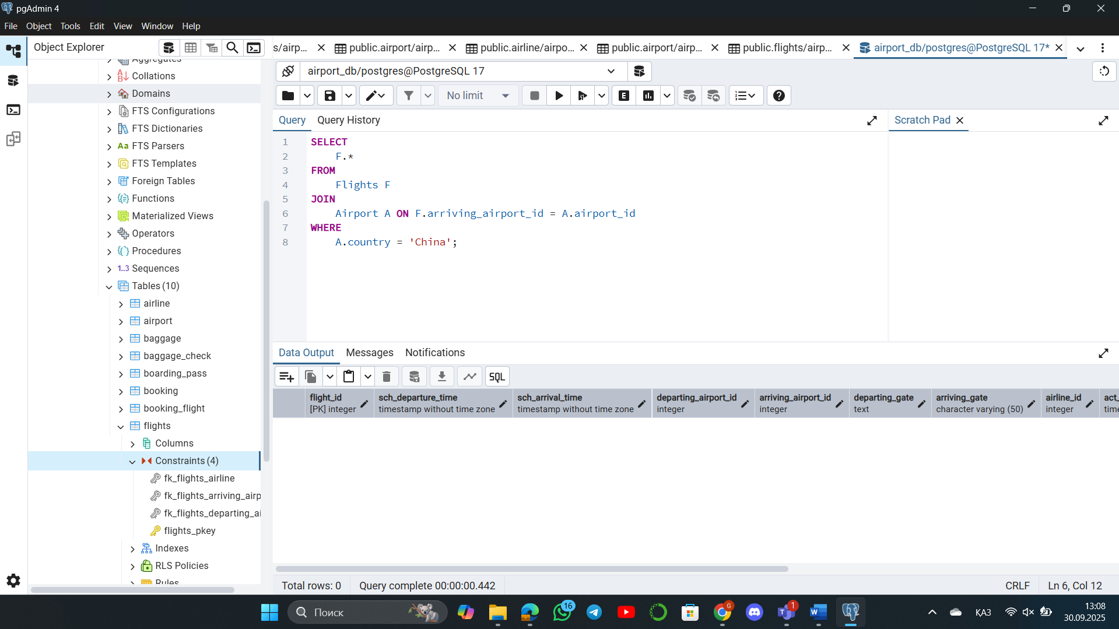

The query was successful but returned no rows. This confirms that the current data does not contain any flights bound for China.

**6. Show airlines from any of: ('France','Portugal','Poland') created between '2023-11-01' and '2024-03-31'.**

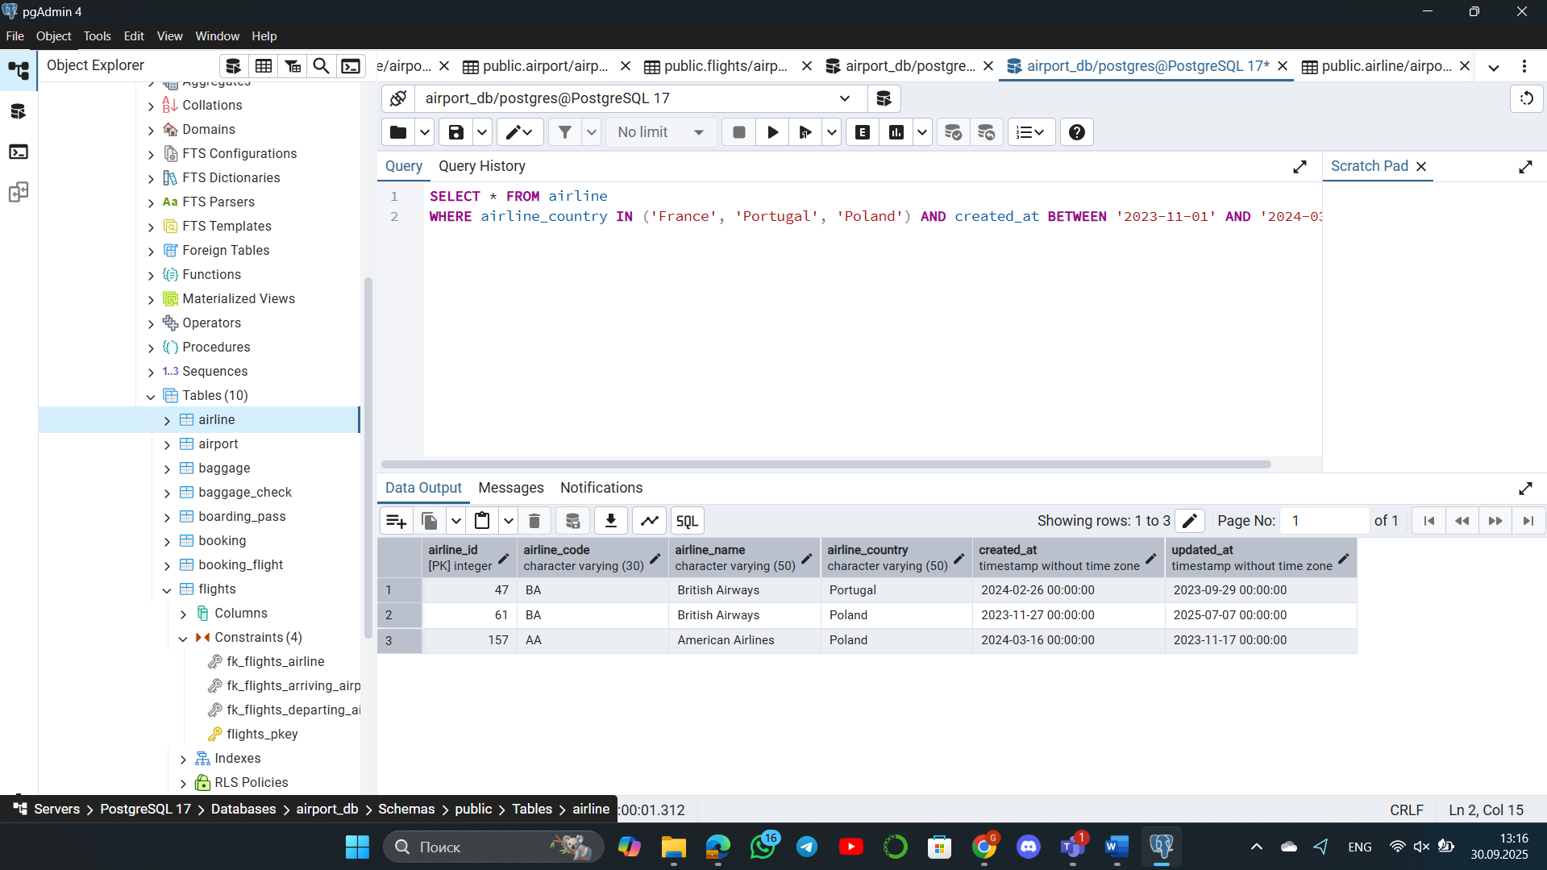

**7. Find all airline names based in Kazakhstan.**

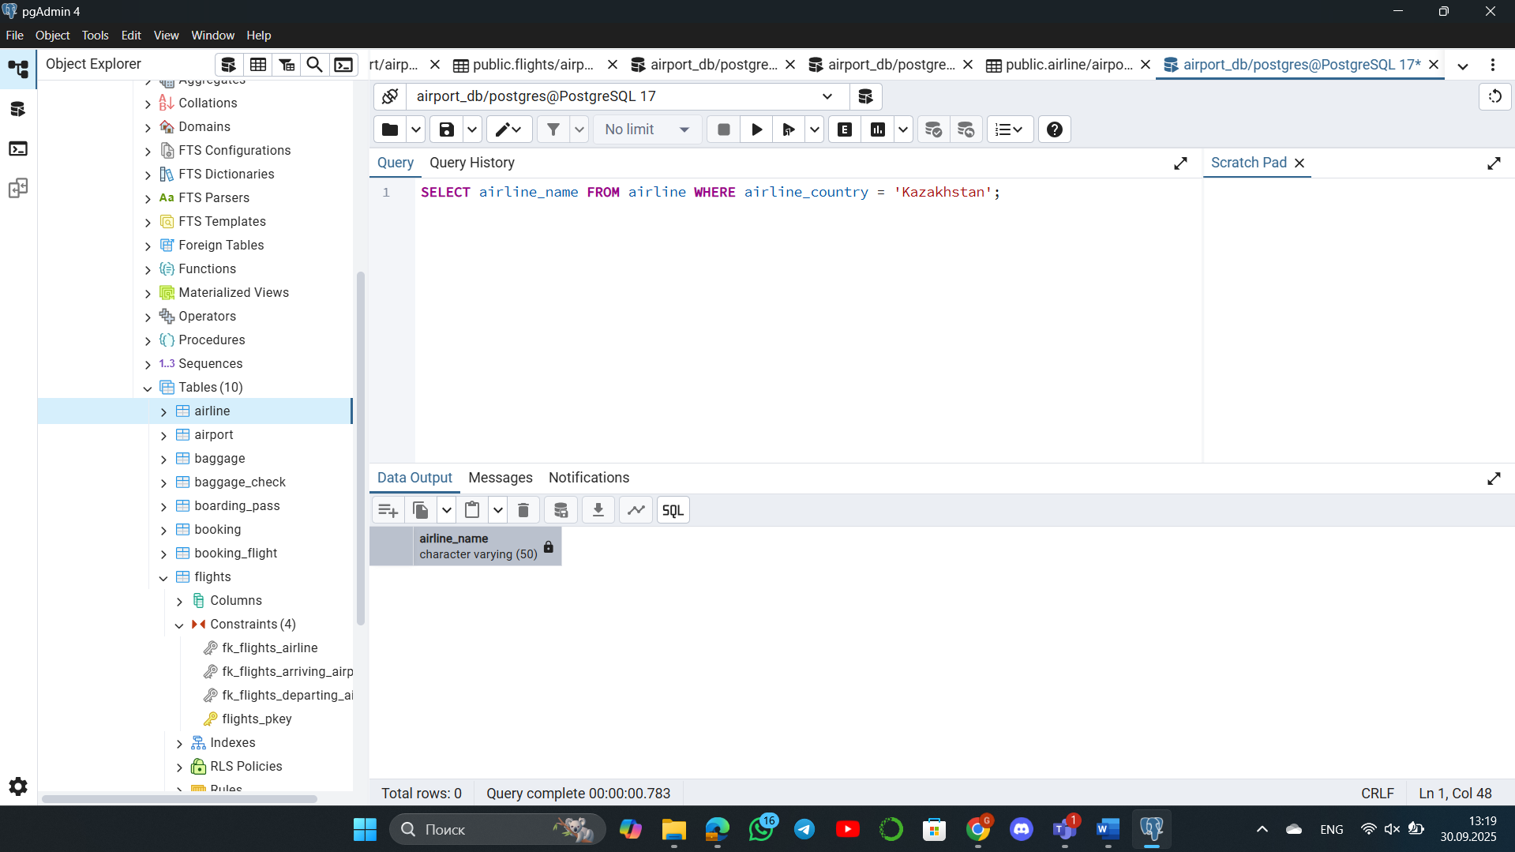

**8. Reduce the cost of booking price by 10% created before ’11-01-2023’.**

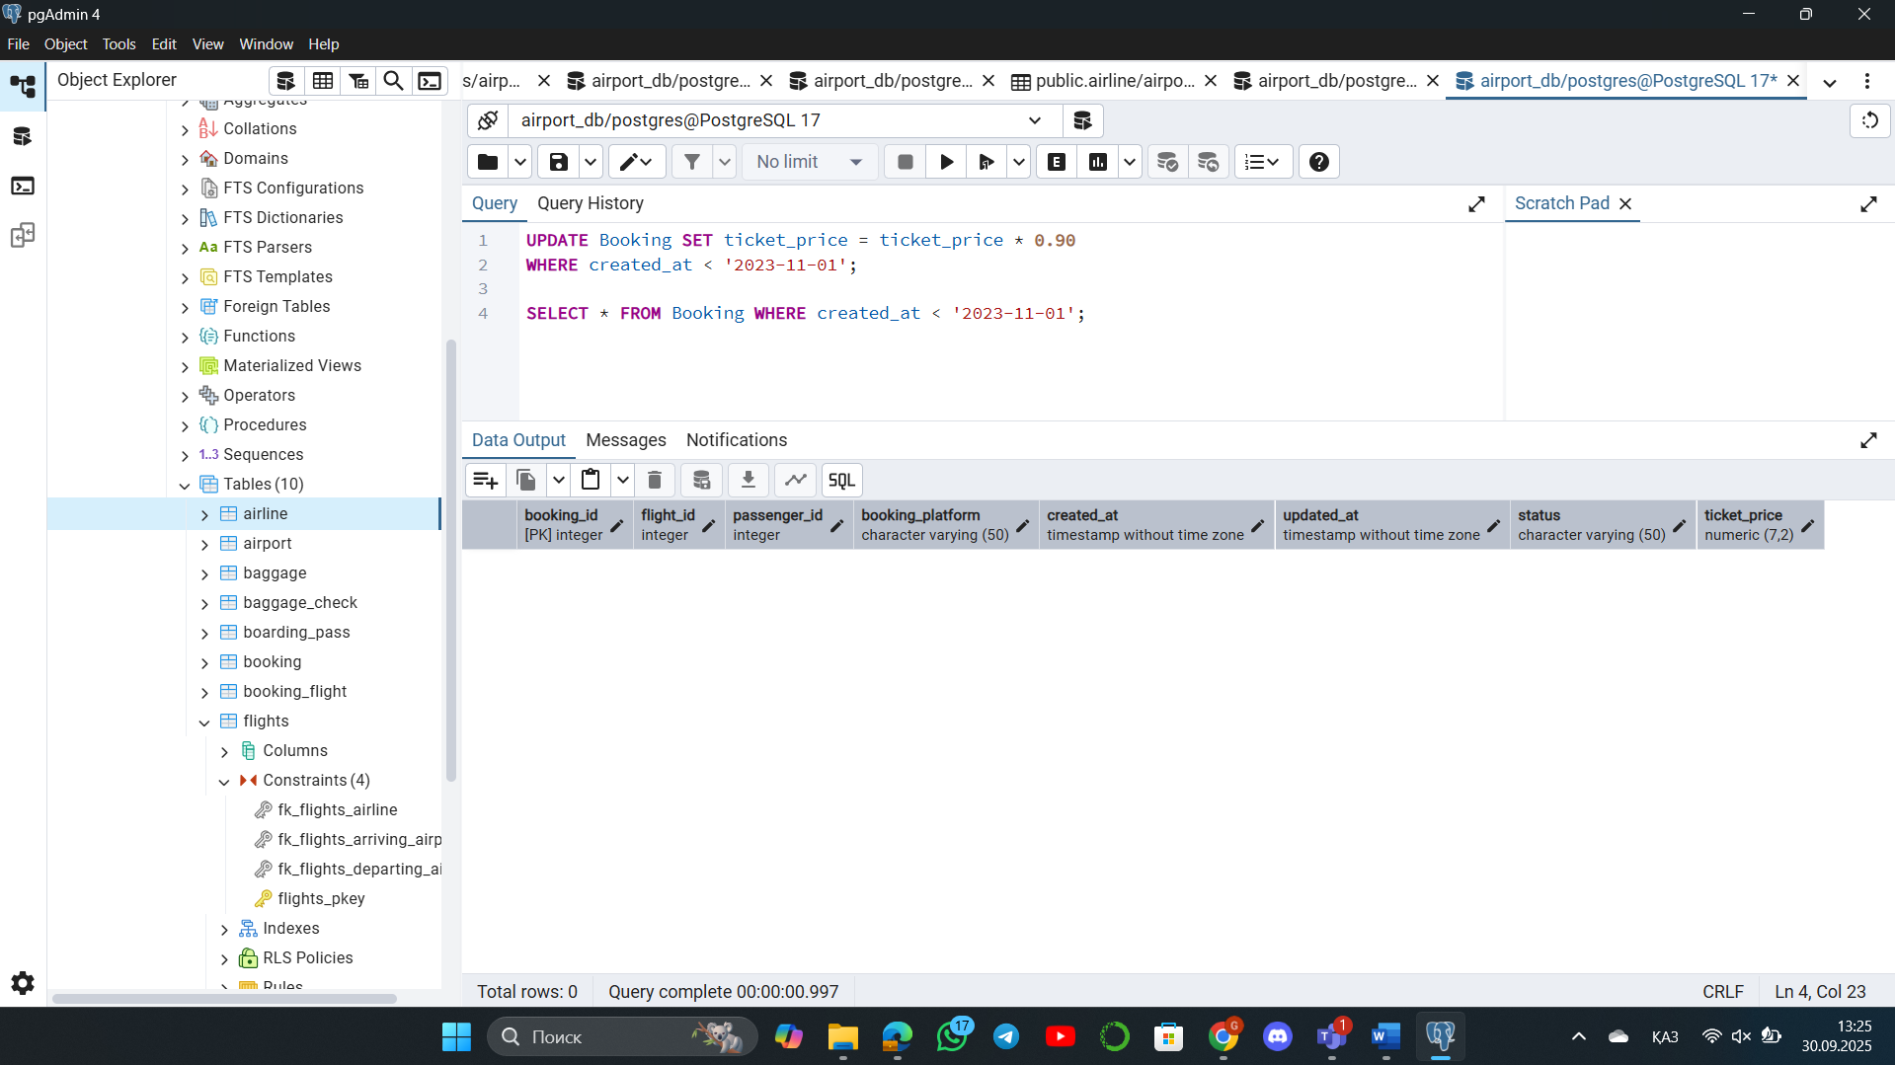

The update query was syntactically correct, but did not affect any rows because there was no data that matched the condition (created before ’11-01-2023’).

**9. Find top3 overweighted baggage with more than 25kg.**

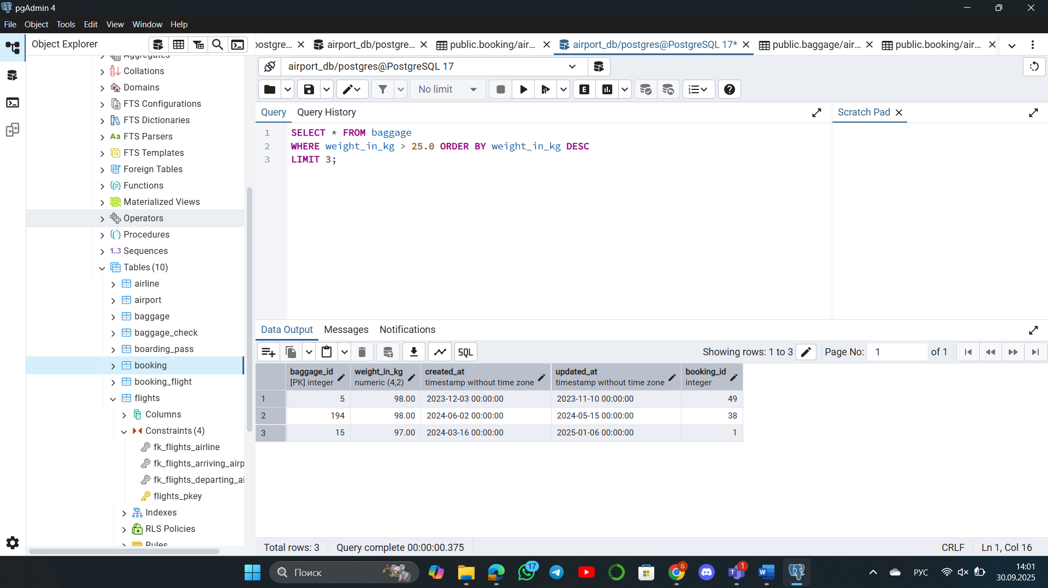

**10. Find the youngest passengers’ full name.**

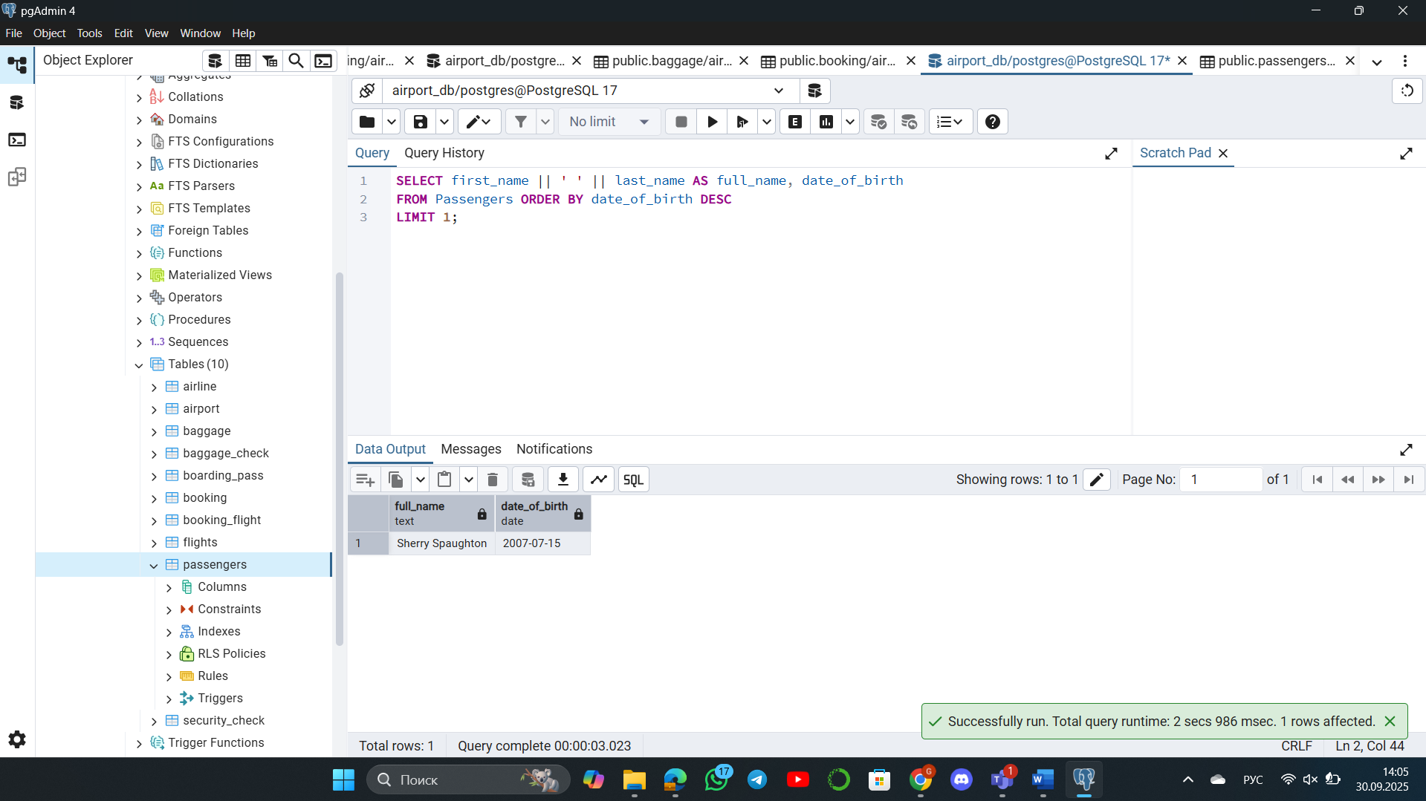

**11. Find the cheapest booking price on each booking platform.**

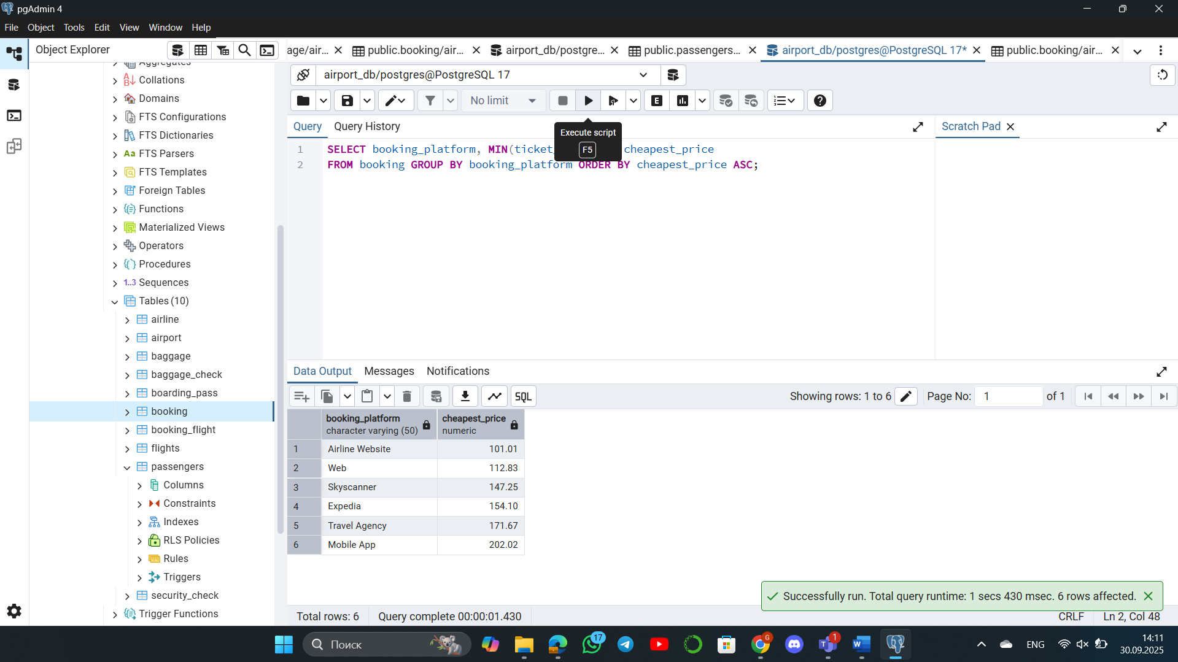

**12. Return airlines whose airline_code contains a digit.**

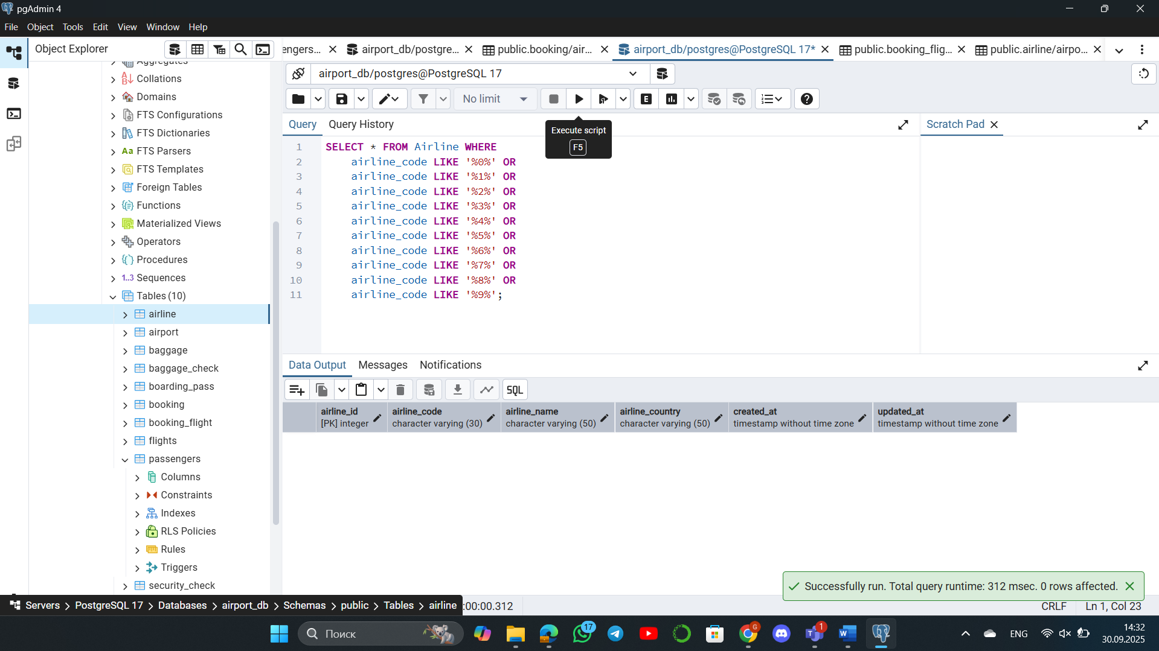

**13. List the top5 most recently created airlines.**

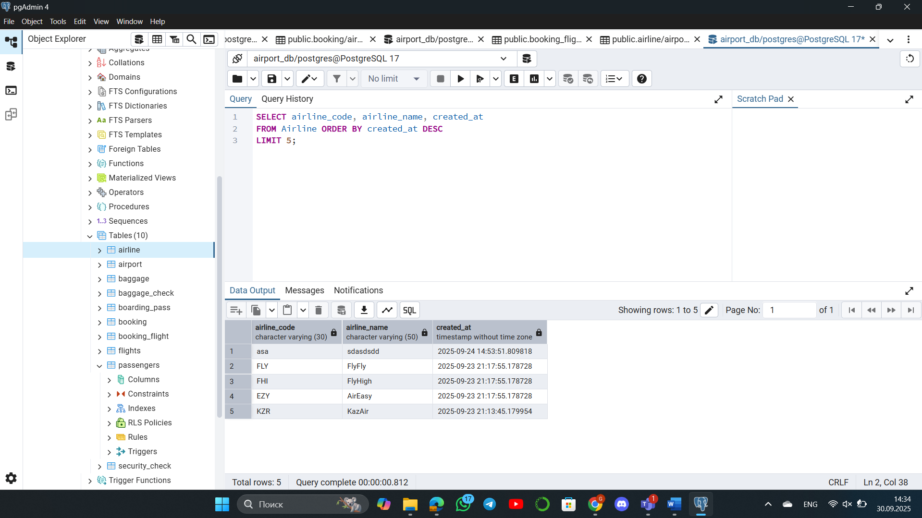

**14. Return all rows where booking_id is between 200 and 300 inclusive and check_result <> 'Checked'.**

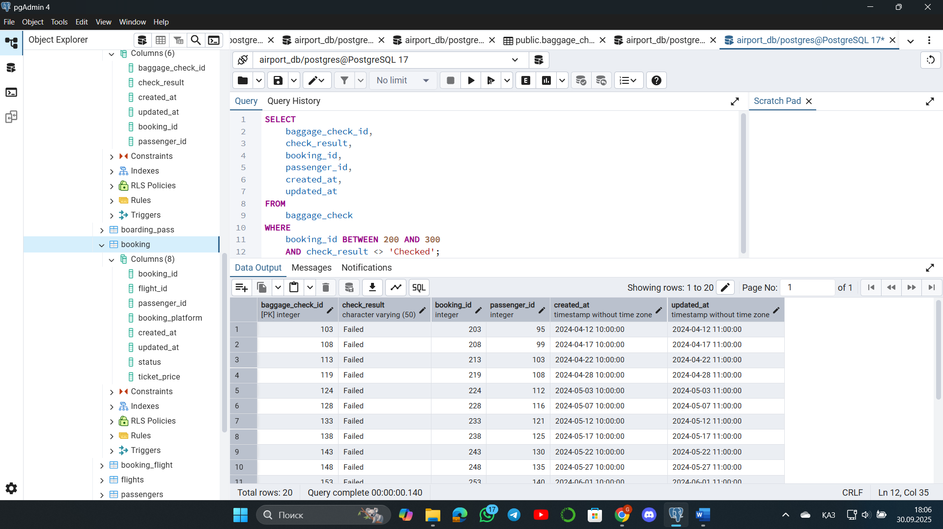

**15. Baggage checks where update_at is in the same month as created_at but occurs earlier than created_at.**

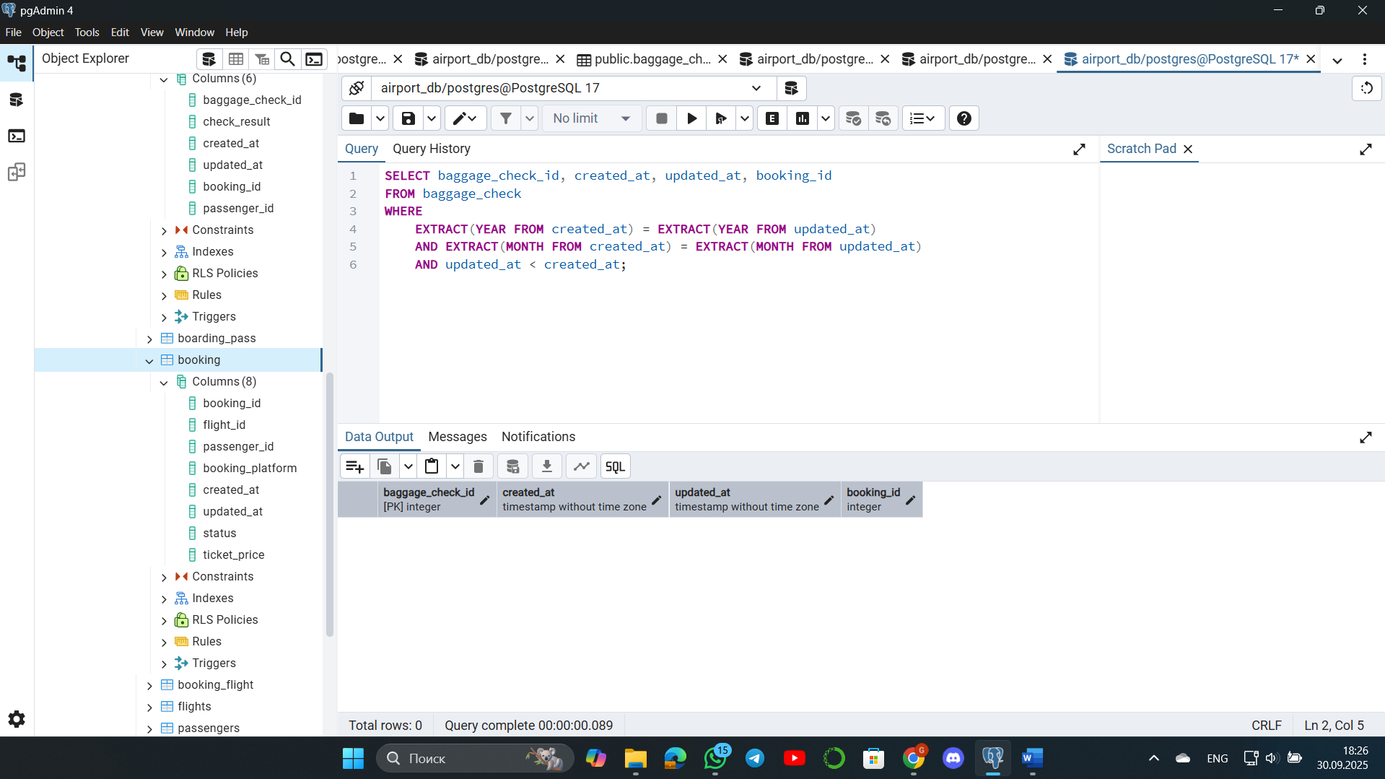

My query returned zero rows (no results). This is because the data used in this database was generated by an AI tool that ensures high data quality, meaning no such chronological errors were intentionally introduced. The AI made sure the update time was always correct (updated_at >= created_at).